30.42: a) When 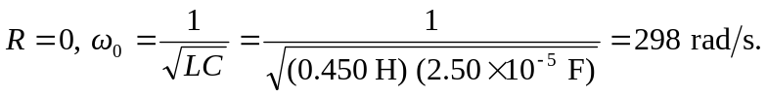
b) We want 